**Ex2 - Loan Amount Prediction Using Linear Regression And Visualize The Interpretation**

**Colab Link:**

[Colab Link](https://colab.research.google.com/drive/1EJ94L06gKKylPuT3zz9lE7tA0LnncVoj?usp=sharing)

**Aim:**

To understand linear regression and implement it in predicting the loan amount of individuals

**Code & Output:**

**Import Dependencies**

import pandas as pd

import numpy as np

**Load the Dataset**

train = pd.read_csv('train.csv')

**Display Sample Rows**

train.head()

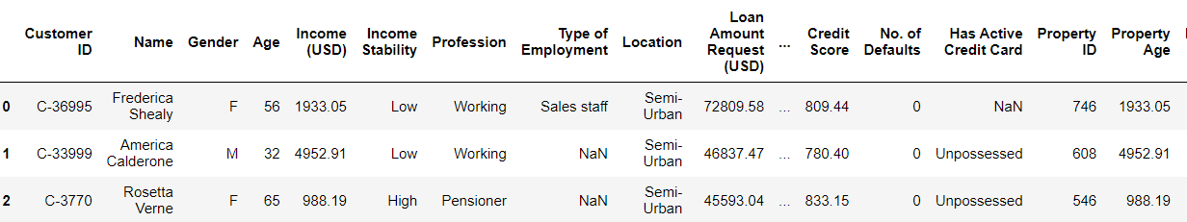

train.info()

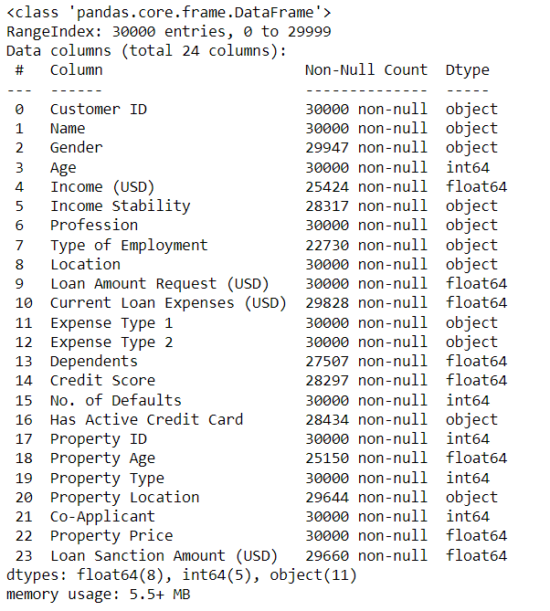

**Graphical Plots**

import matplotlib.pyplot as plt

import seaborn as sns

# Distribution of Numerical Features

numerical_features = ['Age', 'Income (USD)', 'Loan Amount Request (USD)', 'Current Loan Expenses (USD)', 'Credit Score', 'No. of Defaults', 'Property Age', 'Property Price', 'Loan Sanction Amount (USD)']

sns.pairplot(train[numerical_features])

plt.show()

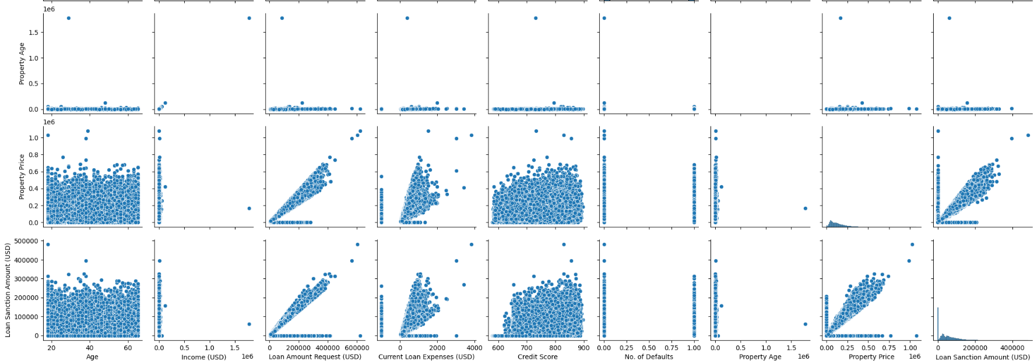

# Correlation Heatmap

plt.figure(figsize=(10, 8))

sns.heatmap(train[numerical_features].corr(), annot=True, cmap='coolwarm', fmt=".2f")

plt.title('Correlation Heatmap of Numerical Features')

plt.show()

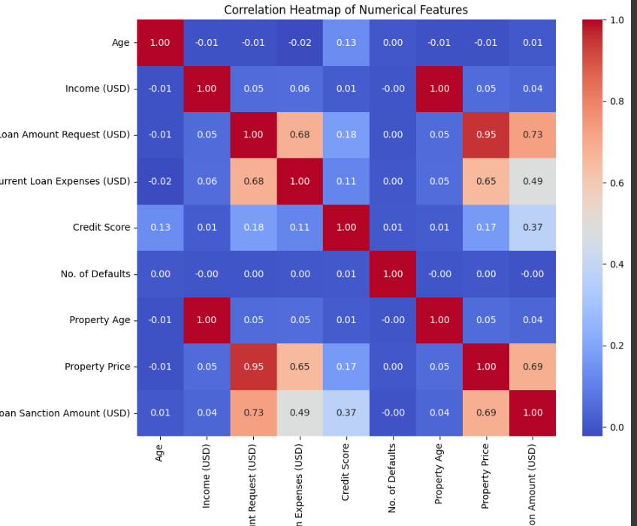

# Count of Categorical Features

categorical_features = ['Gender', 'Income Stability', 'Profession', 'Type of Employment',

'Location', 'Expense Type 1', 'Expense Type 2', 'Property Type',

'Property Location', 'Has Active Credit Card', 'Co-Applicant']

for feature in categorical_features:

plt.figure(figsize=(8, 6))

sns.countplot(data=train, x=feature)

plt.title(f'Count of {feature}')

plt.xticks(rotation=45)

plt.show()

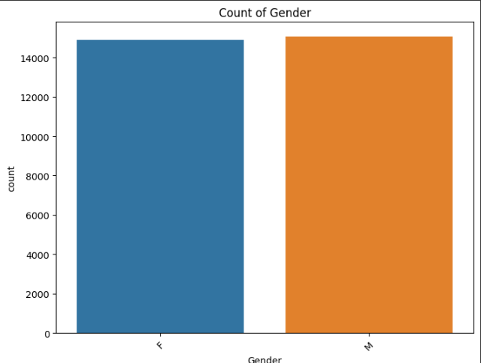

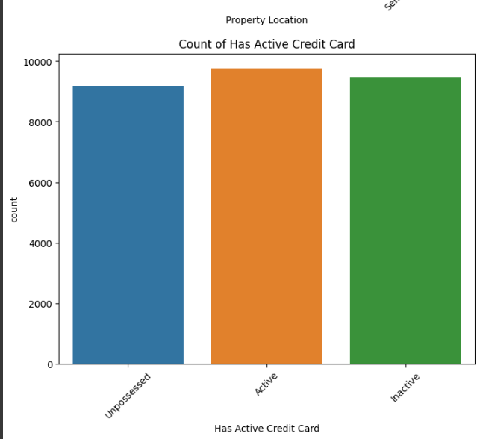

# Relationship between Categorical Features and Loan Sanction Amount

for feature in categorical_features:

plt.figure(figsize=(10, 6))

sns.boxplot(data=train, x=feature, y='Loan Sanction Amount (USD)')

plt.title(f'{feature} vs. Loan Sanction Amount')

plt.xticks(rotation=45)

plt.show()

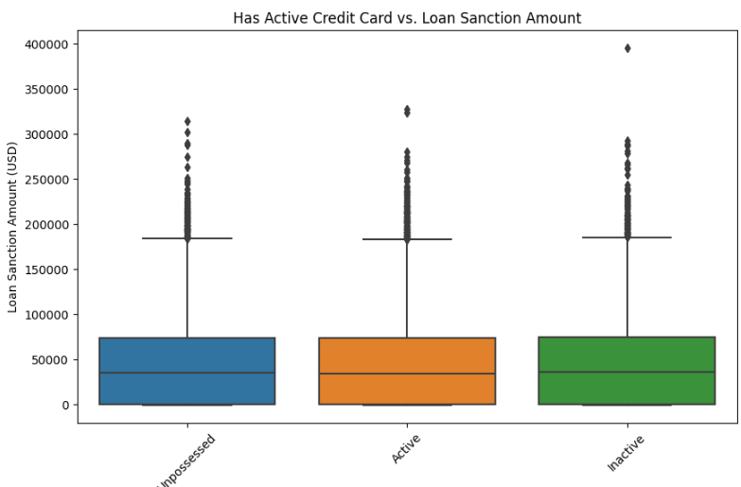

**Pre Processing (Handling missing values, Encoding, Normalization, Standardization)**

**Print Columns**

train.columns

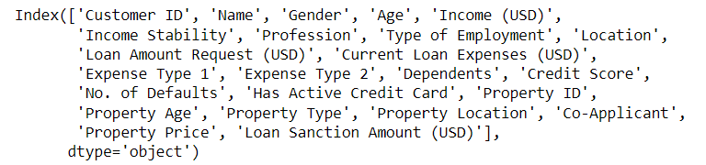

**Print Index**

train.index



**Drop Uncessary Columns**

train = train.drop(['Customer ID','Name','Gender','Income Stability','Profession','Type of Employment','Location','Expense Type 1','Expense Type 2','Dependents','Has Active Credit Card','Property ID','Property Age','Property Type','Property Location','Co-Applicant'],axis=1)

**Print Null Values**

train.isna()

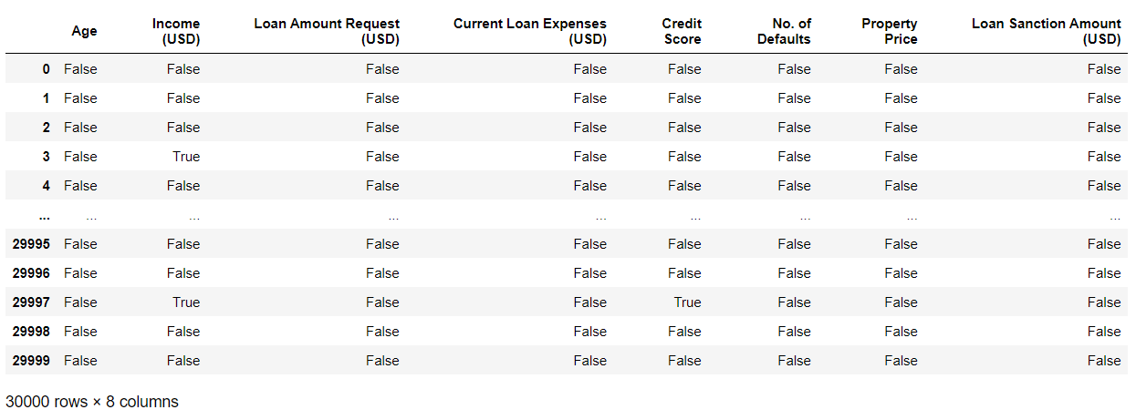

arr = np.array(train.columns)

arr

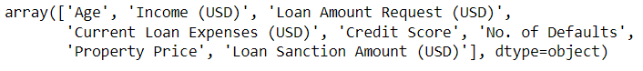

**Print Column and NULL Count**

for index in range(len(arr)):

count = train[train[arr[index]].isna() == True].shape[0]

if(count != 0):

print(f"{arr[index]}\t{count}")

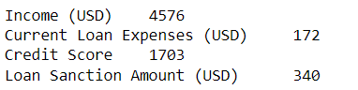\

**Handling NULL Values**

**Fill With Mean Values**

train["Age"].fillna(train["Age"].mean(), inplace=True)

train["Income (USD)"].fillna(train["Income (USD)"].mean(), inplace=True)

train["Loan Amount Request (USD)"].fillna(train["Loan Amount Request (USD)"].mean(),inplace=True)

train["Loan Sanction Amount (USD)"].fillna(train["Loan Sanction Amount (USD)"].mean(),inplace=True)

train["Current Loan Expenses (USD)"].fillna(train["Current Loan Expenses (USD)"].mean(),inplace=True)

train["Credit Score"].fillna(train["Credit Score"].mean(),inplace=True)

**Replace Outlier Values**

train["Loan Amount Request (USD)"].replace(-999,train["Loan Amount Request (USD)"].mean())

train["Loan Sanction Amount (USD)"].replace(-999,train["Loan Sanction Amount (USD)"].mean())

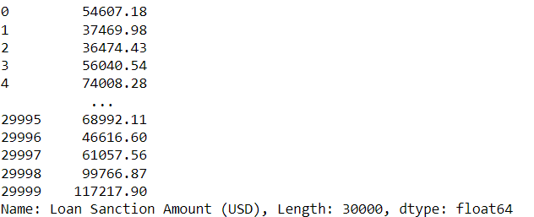

**Drop Column To Be Predicted**

y = train["Loan Sanction Amount (USD)"]

y

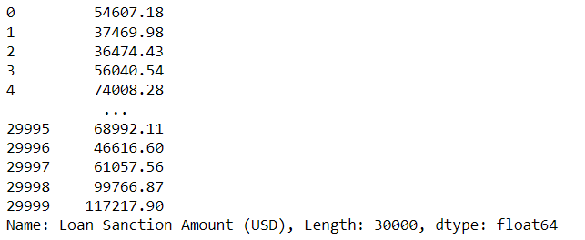

train = train.drop(["Loan Sanction Amount (USD)"],axis=1)

**Model**

train.info()

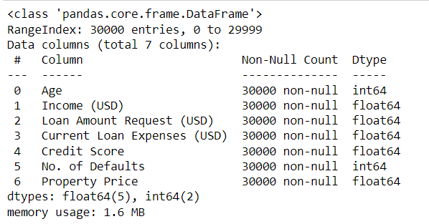

from sklearn.model_selection import train_test_split

from sklearn.linear_model import LinearRegression

from sklearn.metrics import mean_squared_error

from sklearn.metrics import mean_absolute_error, r2_score

from sklearn.metrics import median_absolute_error, explained_variance_score

# Define features (X) and target variable (y)

X = train[['Age', 'Income (USD)', 'Loan Amount Request (USD)', 'Current Loan Expenses (USD)', 'Credit Score', 'No. of Defaults', 'Property Price']]

# Split the data into training and testing sets

X_train, X_test, y_train, y_test = train_test_split(X, y, test_size=0.3, random_state=42)

# Initialize the linear regression model

model = LinearRegression()

# Train the model

model.fit(X_train, y_train)

# Predict on the test set

y_pred = model.predict(X_test)

# Evaluate the model

mse = mean_squared_error(y_test, y_pred)

print('Mean Squared Error:', mse)

# Calculate Mean Absolute Error

mae = mean_absolute_error(y_test, y_pred)

print('Mean Absolute Error:', mae)

# Calculate R-squared

r2 = r2_score(y_test, y_pred)

print('R-squared:', r2)

# Calculate Median Absolute Error

medae = median_absolute_error(y_test, y_pred)

print('Median Absolute Error:', medae)

# Calculate Explained Variance Score

evs = explained_variance_score(y_test, y_pred)

print('Explained Variance Score:', evs)

# Score the model on the test set

score = model.score(X_test, y_test)

print('Model Score (R-squared):', score)

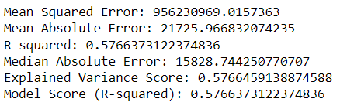

import matplotlib.pyplot as plt

import seaborn as sns

# Residual Plot

residuals = y_test - y_pred

plt.figure(figsize=(8, 6))

sns.scatterplot(x=y_pred, y=residuals)

plt.axhline(y=0, color='r', linestyle='--')

plt.title('Residual Plot')

plt.xlabel('Predicted Values')

plt.ylabel('Residuals')

plt.show()

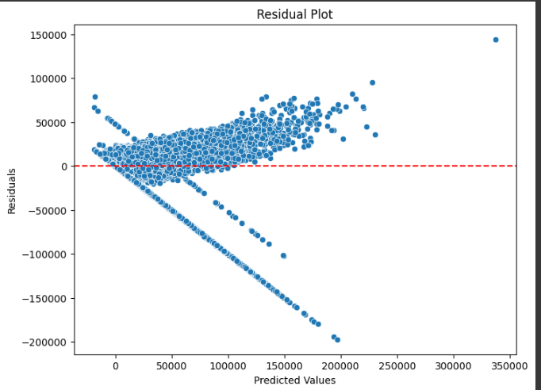

# Actual vs. Predicted Values Plot

plt.figure(figsize=(8, 6))

sns.scatterplot(x=y_test, y=y_pred)

plt.plot([y_test.min(), y_test.max()], [y_test.min(), y_test.max()], color='r', linestyle='--')

plt.title('Actual vs. Predicted Values')

plt.xlabel('Actual Values')

plt.ylabel('Predicted Values')

plt.show()

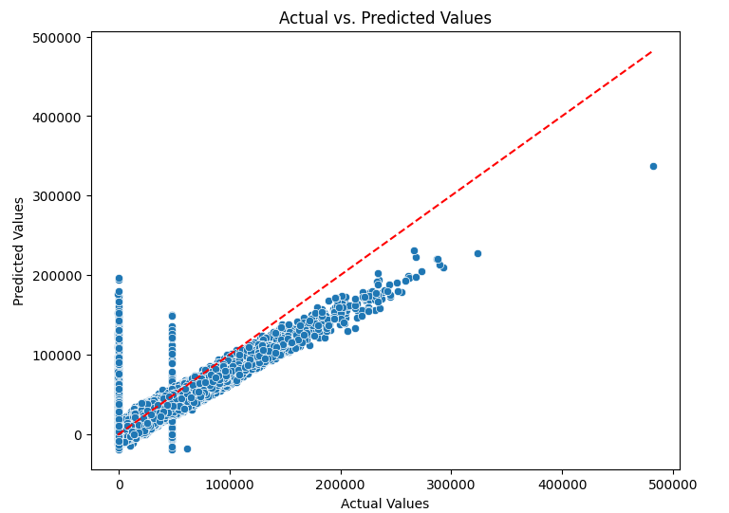

# Distribution Plot of Residuals

plt.figure(figsize=(8, 6))

sns.histplot(residuals, kde=True)

plt.title('Distribution Plot of Residuals')

plt.xlabel('Residuals')

plt.ylabel('Frequency')

plt.show()

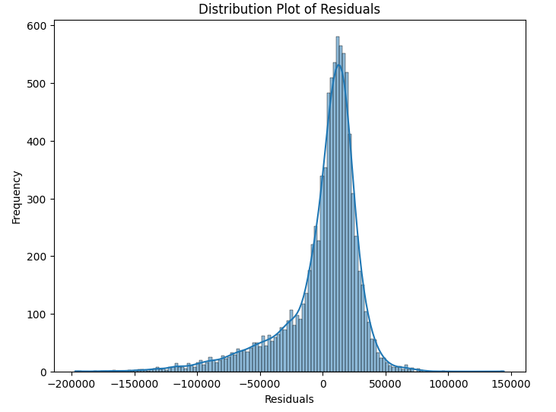

import matplotlib.pyplot as plt

import numpy as np

# Scatter plot of actual vs. predicted loan sanction amount

plt.figure(figsize=(10, 6))

plt.scatter(y_test, y_pred, color='blue', alpha=0.5)

plt.plot([min(y_test), max(y_test)], [min(y_test), max(y_test)], color='red', linestyle='--')

plt.xlabel('Actual Loan Sanction Amount (USD)')

plt.ylabel('Predicted Loan Sanction Amount (USD)')

plt.title('Actual vs. Predicted Loan Sanction Amount')

plt.grid(True)

plt.show()

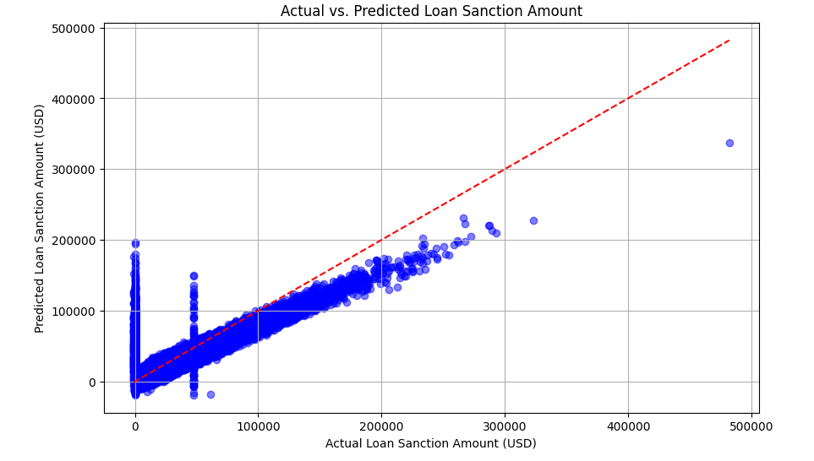

**Test**

test = pd.read_csv('test.csv')

test.head()

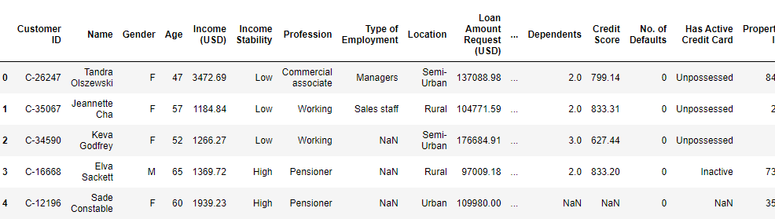

test.columns

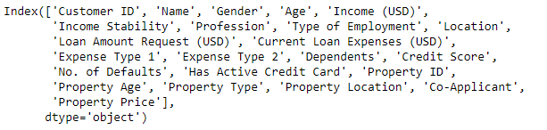

# Preprocess the test data, selecting the same features as in the training data

test_features = test[['Age', 'Income (USD)', 'Loan Amount Request (USD)', 'Current Loan Expenses (USD)',

'Credit Score', 'No. of Defaults', 'Property Price']]

# Replace '?' with NaN

test_features.replace('?', float('nan'), inplace=True)

# Convert object columns to numeric

test_features = test_features.apply(pd.to_numeric, errors='coerce')

# Fill missing values with mean

test_features.fillna(test_features.mean(), inplace=True)

# Make predictions on the processed test data

test_predictions = model.predict(test_features)

# Add the predictions to the test dataframe

test['Predicted Loan Sanction Amount (USD)'] = test_predictions.round(2)

test.head()

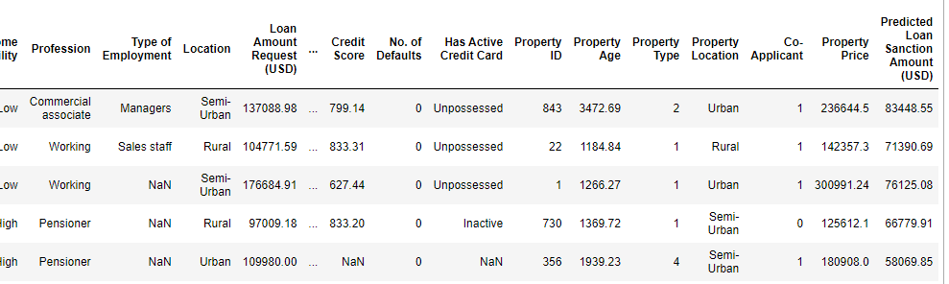

test['Predicted Loan Sanction Amount (USD)']

